文章链接：<http://jingyan.baidu.com/article/1709ad80a8caf14634c4f013.html>

文章链接：<https://my.oschina.net/zhailibao2010/blog/529887>

1. 修改MySQL的配置文件（默认为/etc/my.cnf）,在[mysqld]下添加一行skip-grant-tables

[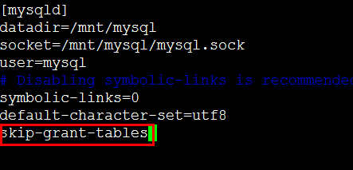](http://jingyan.baidu.com/album/1709ad80a8caf14634c4f013.html?picindex=1)

1. 2

保存配置文件后，重启MySQL服务 service mysqld restart

[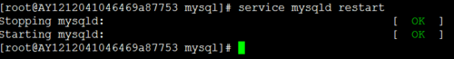](http://jingyan.baidu.com/album/1709ad80a8caf14634c4f013.html?picindex=2)

1. 3

再次进入MySQL命令行 mysql -uroot -p,输入密码时直接回车，就会进入MySQL数据库了，这个时候按照常规流程修改root密码即可。

[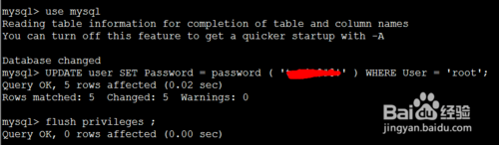](http://jingyan.baidu.com/album/1709ad80a8caf14634c4f013.html?picindex=3)

1. 4

密码修改完毕后，再按照步骤1中的流程，删掉配置文件中的那行，并且重启MySQL服务，新密码就生效了。

* 操作系统：
* [root@localhost ~]# cat /etc/redhat-release

CentOS Linux release 7.1.1503

* mysql 版本5.7.9
* mysql> select version()
* -> ;
* +-----------+
* | version() |
* +-----------+
* | 5.7.9 |
* +-----------+

1 row in set (0.00 sec)

* 安装mysql的yum repo 源：

rpm -ivh http://repo.mysql.com//mysql57-community-release-el7-7.noarch.rpm

* 安装mysql
* yum install mysql-community-server

yum install mysql-community-client

* 修改mysql 配置文件跳过密码验证
* [mysqld]
* skip-grant-tables

skip-networking

* 启动mysql：

systemctl start mysqld

* 匿名登录mysql 设置root密码：
* [root@localhost ~]# mysql
* Welcome to the MySQL monitor. Commands end with ; or \g.
* Your MySQL connection id is 2
* Server version: 5.7.9 MySQL Community Server (GPL)
* Copyright (c) 2000, 2015, Oracle and/or its affiliates. All rights reserved.
* Oracle is a registered trademark of Oracle Corporation and/or its
* affiliates. Other names may be trademarks of their respective
* owners.
* Type 'help;' or '\h' for help. Type '\c' to clear the current input statement.
* mysql> update mysql.user set PASSWORD=PASSWORD('test') where user='root' and host='localhost';
* ERROR 1054 (42S22): Unknown column 'PASSWORD' in 'field list'
* mysql> ALTER USER 'root'@'localhost' IDENTIFIED BY 'test' ;
* ERROR 1131 (42000): You are using MySQL as an anonymous user and anonymous users are not allowed to change passwords
* mysql> update mysql.user set authentication_string=PASSWORD('test') where user='root' and host='localhost';
* Query OK, 1 row affected, 1 warning (0.07 sec)
* Rows matched: 1 Changed: 1 Warnings: 1
* mysql> flush privileges;
* Query OK, 0 rows affected (0.06 sec)
* mysql> exit;

Bye

* 取消跳过密码认证：
* [mysqld]
* #skip-grant-tables

#skip-networking

* 重启mysql：

systemctl restart mysqld

* 必须使用alter user 重置密码：
* mysql> show databases;

ERROR 1820 (HY000): You must reset your password using ALTER USER statement before executing this statement.

* 重新设置密码：

mysql> ALTER USER 'root'@'localhost' IDENTIFIED BY '********'

* 密码需要复杂度要求：
* mysql> SHOW VARIABLES LIKE 'validate_password%';
* +--------------------------------------+--------+
* | Variable_name | Value |
* +--------------------------------------+--------+
* | validate_password_dictionary_file | |
* | validate_password_length | 8 |
* | validate_password_mixed_case_count | 1 |
* | validate_password_number_count | 1 |
* | validate_password_policy | MEDIUM |
* | validate_password_special_char_count | 1 |
* +--------------------------------------+--------+

6 rows in set (0.00 sec)

ERROR 1820 (HY000): You must SET PASSWORD before executing this statement  
mysql> set password=password('xxxx');  
Query OK, 0 rows affected (0.00 sec)